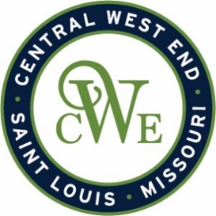
CWE Marketing Committee Meeting
Sept. 2, 2026
Agenda

Notice is hereby given that the CWE BUSINESS COMMUNITY IMPROVEMENT DISTRICT and EUCLID SOUTH COMMUNITY IMPROVEMENT DISTRICT will conduct a Marketing Committee meeting on Sept. 2nd , at 412-B N. Euclid Ave. St. Louis, MO 63108

- Welcome

- CWE Marketing Program Updates

- CWE App Update
- Media Updates / Opportunities
  - SLM
  - St. Louis Bucket List
  - De Miranda Productions
  - Alexis Zotos
  - Yelp/Trip Advisor
- Window Mural Project

- Event Updates
  - CWE Jazz and Blues
  - CWE Gallery Night - Sept. 11th
  - CWE Art and Taste – Oct. 3rd
  - Halloween – October 31st
  - Window Walk - December 5th, 12th and 19th

- Other Business
