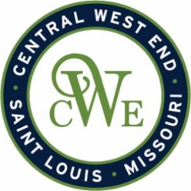
CWE Marketing Committee Meeting
July 9, 2026
Agenda

Notice is hereby given that the CWE BUSINESS COMMUNITY IMPROVEMENT DISTRICT and EUCLID SOUTH COMMUNITY IMPROVEMENT DISTRICT will conduct a Marketing Committee meeting on July 9th, at 412-B N. Euclid Ave. St. Louis, MO 63108

- Welcome

- CWE Marketing Program Updates

- CWE App Update
- Map and Directories
- Media Updates
  - SLM
  - St. Louis Bucket List
- Window Mural Project
- CWE Merchant Meeting – July 15th

- Upcoming Events
  - CWE Bourbon Passport
  - Red Lantern – July 18th
  - Jazz and Blues – August 15th
  - CWE Cocktail Crawl – August 29th
  - CWE Art and Taste – Oct. 3rd

- Other Business
