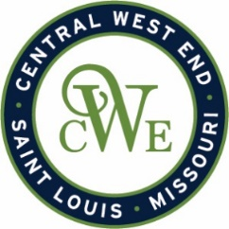
CWE Marketing Committee Meeting
March 11, 2026
Agenda

Notice is hereby given that the CWE BUSINESS COMMUNITY IMPROVEMENT DISTRICT and EUCLID SOUTH COMMUNITY IMPROVEMENT DISTRICT will conduct a Marketing Committee meeting on March 11, 2026, at 412-B N. Euclid Ave. St. Louis, MO 63108

- Welcome

- CWE Marketing Program Updates

- CWE App Recap and Discussion
- Map and Directories
- Media Plan

- Upcoming Events
  - CWE Cocktail Crawl
  - Back in Bloom

- New Business Openings

- Other Business
