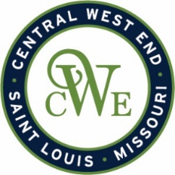
CWE Marketing Committee Meeting
July 8, 2025 – 2:00 PM
Agenda

Notice is hereby given that the CWE BUSINESS COMMUNITY IMPROVEMENT DISTRICT and EUCLID SOUTH COMMUNITY IMPROVEMENT DISTRICT will conduct a Marketing Committee meeting on July 8, 25 at 2:00 pm. at 412B N. Euclid Ave. St. Louis, MO 63108
- Welcome
- Marketing Program Updates
  - Website
  - Photo shoots
  - Influencer Campaign
  - Media

- Events
  - CWE Music Series
  - Red Lantern – July 19
  - CWE Jazz & Blues – Sept. 6th
  - Twist of Tequila – Sept. 2
  - Window Walk / Holiday Market

- Euclid Shuttle

- New Business Openings

- CWE Merchant Meeting – July 30th

- Other Business
