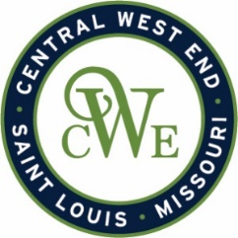
CWE Marketing Committee Meeting
March 6, 2025 – 2:00 PM
Agenda

Notice is hereby given that the CWE BUSINESS COMMUNITY IMPROVEMENT DISTRICT and EUCLID SOUTH COMMUNITY IMPROVEMENT DISTRICT will conduct a Marketing Committee meeting on March 6, 2025, at 2:00 pm. at 412B N. Euclid Ave. St. Louis, MO 63108
- Welcome
- CWESCENE Marketing Program Review
- 2025-2026 Contract
- Up Coming Events
- Review of existing events and tentative schedule
  - 314 Day
  - Back In Bloom - April 5
  - Music Series – May through Sept (Wednesdays and Fridays)
- Next Merchant Meeting – March 26th AC Hotel
- Euclid Shuttle
- Other Business

