**CWE Cocktail Party and Cocktail Competition**

**2025 Sponsor Opportunities**

The Central West End Cocktail Party - Celebrating the home of the 1st cocktail party in history! The CWE Cocktail Party and Cocktail Competition will take place on June 14th 2025 5:00 pm– 10:00 pm. The event will take place along Euclid between Maryland and McPherson and will feature cocktails, food, live music, dancing, street performers and a cocktail competition.

Sponsorship opportunities include: Sponsoring the event, sponsoring an element of the event and selling food and/or beverages. Sponsorships may be crafted for each sponsor to maximize the benefit on both parties.

**Presenting Sponsor - $7,000**

* Opportunity to have sponsoring spirit in one round of the cocktail competition
* Opportunity to have brand offered at participating vendor booths
  + Businesses selling Presenting Sponsor spirits will be offered a discount on the booth fee.
* Logo present on all menu boards
* Seat on the Cocktail Competition judges panel
* Opportunity to speak at the event.
* Premium placement of logo on the main stage and competition stage
* Premium logo placement on the CWEScene.com website, poster, flyer and banners
* Logo placement on all print advertising (Billboard, print & digital ads)
* Logo included in event e-blast

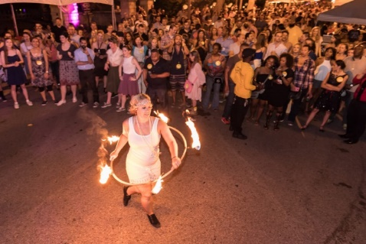 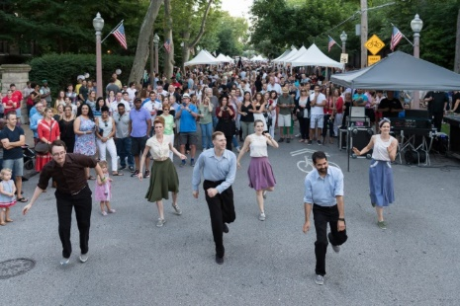 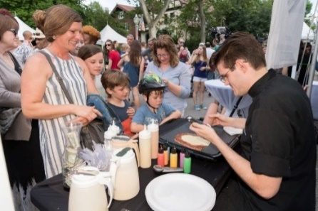

**Photo Booth Sponsor $3,000**

* Logo included on photos taken in the photo booth and given to attendees (photos are free of charge to all attendees)
* Logo placement on website, poster, flyer and main stage banners
* Logo included in event e-blast
* 10 x 10 space next to the photo booth at the event

**Cocktail Competition Sponsor - $2,500**

* Sponsoring spirit to be used in one round of the cocktail competition
* Logo placement on the Cocktail Competition signage
* Opportunity to judge the cocktail competition.
* Logo placement on all posters, flyers, website and main stage banners
* Logo included in event e-blast & recognition on social media

**Lounge Sponsor - $2,000**

* Logo placement on lounge signage and opportunity to be present in the lounge area to promote product.
* Logo on all posters, flyers, website and main stage banners
* Logo included in event e-blast & recognition on social media

**Community Partner - $1,000**

* Logo placement on all posters, flyers, website and main stage banners
* Logo included in event e-blast & recognition on social media

**CWE Cocktail Party and Cocktail Competition**

**2025 Sponsor Confirmation Form**

Company: ______________________________________________________

Contact Name: __________________________________________________

Address: _______________________________________________________

Phone: ________________________________________________________

Email: _________________________________________________________

______ Yes! I would like to Sponsor the CWE Cocktail Party

Sponsor Level: _________________________________________________

An invoice will be sent via email to the email address provided above.

Checks should be payable to the CWE Business Community Improvement District.

Sponsors logos will appear on marketing pieces as defined in the sponsor packet. Please send your logo to [Kate.haher@cwenorthcid.com](mailto:Kate.haher@cwenorthcid.com). High resolution EPS files of a transparent and color logo are required.

Please contact Kate Haher, Executive Director, CWE Business Community Improvement District with any questions. 314-305-4012