CWE Cocktail Party and Cocktail Competition
Sponsor Opportunities

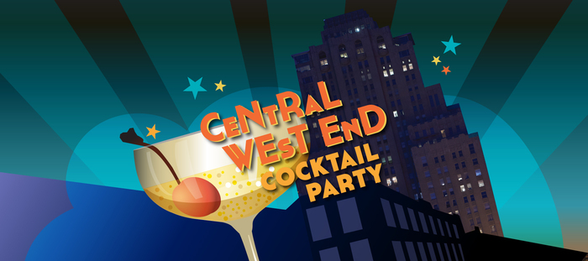

  - The Central West End Cocktail Party - Celebrating the home of the 1st cocktail party in history! The CWE Cocktail Party and Cocktail Competition will take place on June 9th, 2018 5:00 pm– 10:00 pm. The event will take place along Euclid between Maryland and McPherson and will feature cocktails, food, live music, dancing, street performers and a cocktail competition.

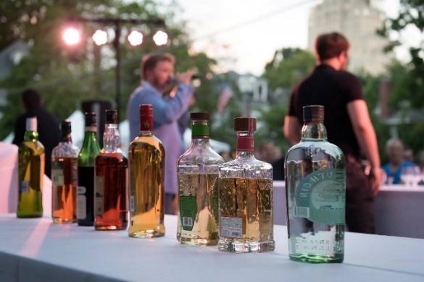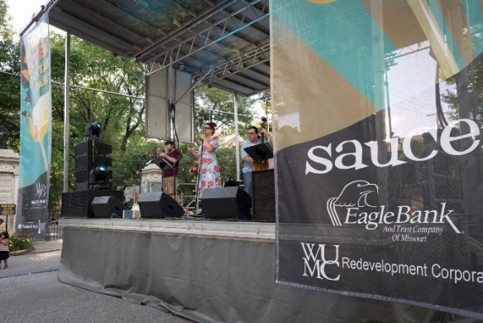
Sponsorship opportunities include: Sponsoring the event, sponsoring an element of the event and selling food and/or beverages. Sponsorships may be crafted for each sponsor to maximize the benefit on both parties.

Presenting Sponsor - $6,000

- Premium placement of Logo on the Main Stage and Competition Stage.
- Speaking opportunity at the event and any cocktail competition events leading up to the main event.
- Opportunity to judge the cocktail competition
- Opportunity to incorporate products into the event (when appropriate)
- Premium logo placement on the CWEScene.com website, poster, flyer and banners
- Logo placement on all print advertising (Billboard, Print)
- Logo included in event e-blast

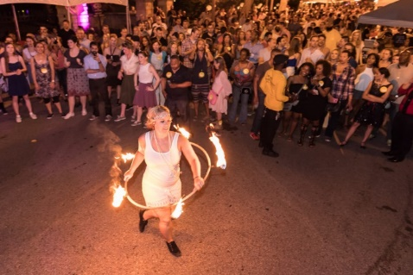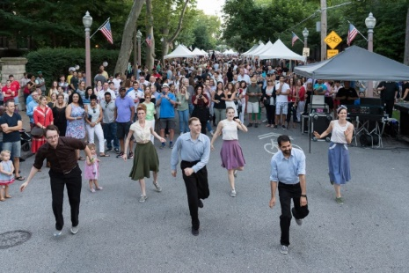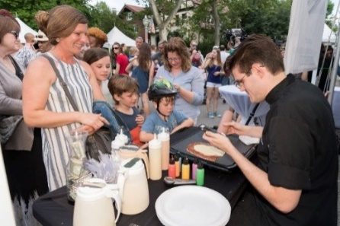

CWE Cocktail Cup Sponsor $4,000
- Logo included on 2500 CWE cocktail cups used at all cocktail party vending booths
- Logo placement on website, poster, flyer and main stage banners
- Sponsor recognition during the event
- Logo included in event e-blast

Photo Booth Sponsor $4,000
- Logo included on photos taken in the photo booth and given to attendees (photos are free of charge to all attendees)
- Logo placement on website, poster, flyer and main stage banners
- Logo included in event e-blast
- 10 x 10 space next to the photo booth at the event

Entertainment Sponsor - $2,500
- Logo placement on website, poster, flyer and main stage banners
- Speaking opportunity at the event and opportunity to introduce the main stage performances
- Logo included in event e-blast & recognition on social media
- 10 x 10 space at the event to promote your business

Family Area Sponsor - $2,500
- Logo placement on all posters, flyers, website and main stage banners
- Signage recognition in Children’s Area
- Logo in included in event e-blast and recognition on social media
- 10 x 10 space at the event to promote your business

Community Partner - $1500
- Logo placement on all posters, flyers, website and main stage banners
- Logo included in event e-blast & recognition on social media

Supporting Sponsors - $500
- Logo placement on posters, flyers and website

CWE Cocktail Party and Cocktail Competition
2018 Sponsor Confirmation Form

Company: ______________________________________________________

Contact Name: __________________________________________________

Address: _______________________________________________________

Phone: ________________________________________________________

Email: _________________________________________________________

______ Yes! I would like to Sponsor the CWE Cocktail Party

Sponsor Level: _________________________________________________

An invoice will be sent via email to the email address provided above.
Checks should be payable to the CWE Business Community Improvement District.

Sponsors logos will appear on marketing pieces as defined in the sponsor packet. Please send your logo to Kate.haher@cwenorthcid.com. High resolution EPS files of a transparent and color logo are required.

Please contact Kate Haher, Executive Director, CWE Business Community Improvement District with any questions. 314-305-4012

